**PREDICTING DIABETES USING MACHINE LEARNING: A COMPARATIVE ANALYSIS OF CLASSIFICATION ALGORITHMS**

**Project: Computer Science (DLMCSPCSP01)**

**Portfolio Phase: Finalisation Phase (Portfolio Part 3)**

**Name: THOUTU SAIRAM**

**Matriculation Number: [**42309508**]**

**GitHub Repository:** [**https://github.com/SairamThout/Computer-Science-Project-DLMCSPCSP01-.git**](https://github.com/SairamThout/Computer-Science-Project-DLMCSPCSP01-.git)

**Table of Contents**

Abstract 3

1. Introduction 4

2. Related work 4

3. Technical Background 6

4. Method 6

4.1 Dataset 6

4.2 Preprocessing 6

4.3 Exploratory Data Analysis (EDA) 7

4.4 Workflow 7

4.5 Tools 7

5. Implementation 7

5.1 Data loading and overview 7

5.2 Exploratory data analysis 8

5.3 Data Preprocessing 12

5.4 Data splitting and model training 13

6. Testing 13

6.1 Model evaluation and cross-validation 13

6.2 Unit testing 15

6.3 Workflow Validation (End-to-End Check) 16

7. Discussion and Limitations 17

7.1 Discussion 17

7.2 Limitations 18

7.2.1 Dataset Size and Generalizability 18

7.2.2 Class Imbalance 18

7.2.3 Limited Feature Scope 18

7.2.4 Interpretability Challenges 18

7.2.5 Overfitting Risk 18

7.2.6 Deployment and Ethical Considerations 19

8. Conclusion and Reflection 19

8.1 Conclusion 19

8.2 Reflection 19

References 20

Appendix: GitHub Repository 21

# Abstract

In this project, the researcher has been using machine learning techniques to predict diabetes, which is a chronic condition with an increased global prevalence. The secondary data collection method is used to collect the Pima Indians Diabetes Dataset, which has various clinical and demographic variables such as glucose levels, BMI, age, and family history. The major agenda is to determine the supervised learning models' effectiveness in developing early diagnosis. The reseracher has been using ***“Logistic Regression, Random Forest, and Gradient Boosting models”***, which were developed with the help of Python and scikit-learn. The performance measure metrics, such as ***“accuracy, precision, recall, F1-score, and ROC-AUC”***, are to be used to underscore the model performance and also use cross-validation to determine the best model. The critical analysis of results shows that the Gradient Boosting model achieved coherent performance, such as 76% accuracy and an ROC-AUC of 0.83 and outperformed the Random Forest and Logistic Regression models on the test set. It is seen from the model evaluation that the Logistic Regression shows a higher mean ROC-AUC (~0.84) in cross-validation, indicating a higher consistency across folds, even though it had lower test performance. These results indicate the trade-off between complicated ensemble models, which are more predictive, and more interpretable simple models, which can be more trustworthy in generalisation. The preprocessing pipeline and the training process were correct as validated via unit testing, and the workflow was reproducible and end-to-end reliable as validated via workflow testing.

# 1. Introduction

Diabetes mellitus is a persistent metabolic disorder that is increasing at an alarming rate all over the world. The World Health Organisation states that over 422 million individuals are already living with diabetes, and this figure is expected to rise considerably in the next few decades. Cardiovascular disease, kidney failure, blindness and amputation of lower limbs are some of the severe complications linked to diabetes, necessitating early diagnosis and treatment to enhance patient outcomes and minimise the cost of healthcare. The research shows that traditional diagnostic tools, such as fasting blood glucose and oral glucose tolerance tests, are effective but resource-intensive, invasive, and did not give any information besides the binary response to the question of whether a patient is diabetic or not. The development of computational techniques and data-driven solutions gives the possibility to boost clinical decision-making. Using machine learning, we can analyse a huge amount of patient data and determine patterns as well as risk factors. It is underscored from the research that a predictive model has the ability to help healthcare professionals in screening individuals who are high risk, as well as to develop preventive interventions before major complications develop. The main agenda of developing this project is to develop ***“supervised machine learning algorithms”*** with the help of the ***“Pima Indians Diabetes Dataset”,*** *a*s well as build logistic regression as a baseline and advanced classifiers such as random forests and gradient boosting. The objective is to determine whether computational methods can reliably assist in the early detection of diabetes and also to assess the possibility of applying them in real-world healthcare processes.

# 2. Related work

This section is established to critically analyse the published journal articles from Google Scholar and underscore the major technological evaluation of machine learning in predicting diabetes, and discover major research gaps. It is underscored from the research that machine learning is a coherent tool for healthcare and giving the ability to analyse critical datasets as well as help clinicians in developing early disease detection. The critical analysis of journals shows that various author uses the Pima Indians Diabetes Dataset for developing the classification models and benchmark (Tasin et al., 2023). Although significant advancements have occurred, the literature shows the existence of recurrent conflicts between predictive performance, interpretability and clinical applicability. The study developed by Naz and Ahuja (2020) uses deep learning methods for predicting diabetes with the help of the Pima dataset, as well as results of the study show cogent accuracy in comparison to the traditional model. The author's work shows the coherent capability of neural networks to determine nonlinear patterns in medical data. Also, this study has some limitations, such as being dependent on the Pima dataset decreases external validity. Also, deep learning methods were considered as black box models, and it was not discussed much about the interpretability to clinicians, which decreases the chances of use in practice.

Also, it is underscored from the research that the machine learning model has cogent capability to accelerate generalizability. Tasin et al. (2023) used several machine learning methods on a real clinical dataset that was gathered in Bangladesh, focusing on accuracy, as well as recall and ROC-AUC. Their work revealed the relevance of recall, specifically in the case of healthcare, where false negatives are especially risky. Although they demonstrated a cogent methodology, but clinical workflow integration was not discussed properly, as well as raising questions about how these systems can be used in day-to-day practice. The other study also shows the efficiency of ensemble methods for diabetes prediction. The study developed by Abnoosian et al. (2023) shows the effectiveness of feature selection and stacked ensembles to gather high accuracy on the Pima dataset. The literature delivers cogent insights on how the study can be methodologically enhanced, mainly through the application of Boruta in feature selection. Also, overfitting and generalizability were concerns due to the use of a small benchmark set and the lack of cross-population testing.

The author Li et al. (2024) show a coherent method for diabetes prediction, such as merging genetic algorithms for hyperparameter optimisation with XGBoost stacking. The critical analysis of the literature shows that hybrid modelling shows coherent performance, which highlights the importance of systematic optimisation methods. Also, the complexity introduced to the algorithm is a possible threat to transparency and reproducibility. It is underscored that the model achieves high performance, but without explainability, making it hard to justify in a clinical environment. Hoyos et al. (2024), on the contrary, directly discussed the problem of explainability in diabetes prediction. Their research integrated statistical analysis with AI techniques and used the tools of interpretability, including ranking features of importance, to confirm that the outputs would be comprehensible to the clinicians. Their approach has helped to eliminate the gaps in technical performance and clinical trust. Also, their data were still small and narrow, implying that they should be expanded with larger, multi-site validation. Collectively, these studies show the development of diabetes prediction research. Older experiments have focused on accuracy, especially on the Pima dataset, but more recent works focus on more advanced optimisation and explainability. Also, the limitations remain: excessive dependence on benchmark data, a lack of focus on workflow integration, and a lack of attention to ethical and bias problems. Our research aims to fill these gaps by balancing performance and interpretability. Here, we compare Logistic Regression, Random Forest, and Gradient Boosting. It aims to not only assess such metrics of prediction as accuracy and AUC but also recall, which is essential in medical diagnosis. Moreover, ROC curves and cross-validation are used to determine the best model. The unit testing has helped to define whether the developed pipeline works correctly or not, and end-to-end workflow validation helps to confirm that the pipeline is accurate for developing predictions.

# 3. Technical Background

In this project, the researcher has used a supervised classification method, such as the model that learn a mapping from patient features X, which are glucose, BMI, to a binary label Y, which states diabetes.

Here, the sigmoid function has been used in Logistic Regression models. The equation outlined below,

*“P(y=1∣X)= (1/1+e-(β0+β1x1+...βnxn))”*

Also, the ensemble of decision trees, such as Random Forest, is trained on the diabetes dataset as well as uses random feature selection to boost accuracy and decrease overfitting. The Gradient Boosting sequentially develop the trees, and every tree corrects the errors of the previous one and decreases loss with the help of gradient descent. To evaluate the model performance, various kinds of performance measure metrics have been used, which are accuracy, precision, recall, F1-score, and ROC-AUC.

**Accuracy**

* *“(TP+TN)/(TP+TN+ FP+FN)”*

**Precision and recall**

* *“(TP)/(TP+FP), (TP)/(TP+FN)”*

**F1-score and ROC & AUC**

* It is the harmonic mean of Precision and Recall.
* Also, the ROC curve and AUC measure discrimination ability.

# 4. Method

## 4.1 Dataset

The methodology of the project was developed to perform a cogent evaluation of machine learning models to predict diabetes on the Pima Indians Diabetes Dataset. The dataset has 768 records of patients, which are characterised by eight numeric health variables and a binary outcome variable that shows whether the patient has diabetes. Such a structure renders the task appropriate to a supervised binary classification problem.

## 4.2 Preprocessing

The critical analysis shows that the dataset has various missing values, which are replaced with the help of median imputation to confirm that the model was not biased with biologically implausible values. The features were then scaled with a z-score to normalise features to a similar scale, which is important when using a model that is sensitive to the magnitude of the features, as is the case with Logistic Regression. Also, the data had a moderate class imbalance, whereby there were fewer positive cases of diabetes corresponded to negative cases. To eliminate this problem, stratified sampling has been used in the process of splitting and model evaluation.

## 4.3 Exploratory Data Analysis (EDA)

Exploratory Data Analysis (EDA) was performed to obtain information about the distributions of features and their relationships. The descriptive statistics gave a generalised idea about the range of the variables, whereas the visuals, like the histograms, displayed that the features like insulin and BMI had skewed distributions. The correlation heatmap was used to determine the possibility of multicollinearity, and it is underscored that glucose and BMI were coherent predictors of diabetes outcome.

## 4.4 Workflow

The researcher uses a cogent pipeline, which has helped to load the dataset, develop preprocessing, as well as use a stratified train–test split (80:20), model training, cross-validation, model evaluation on the test set and uses unit testing to underscore the efficiency of the workflow. The reseracher has been using Logistic Regression as a baseline, as well as Random Forest as a bagging-based ensemble, and Gradient Boosting as a boosting-based ensemble.

## 4.5 Tools

The researcher has been using the Jupyter notebook environment to develop the implementation and testing. Also, uses Python libraries such as Pandas and NumPy for data handling, matplotlib and seaborn for visualisation, such as EDA, ROC curves, scikit-learn helps in model training and evaluation as well as pytest is used for unit testing. This methodological structure made it possible to conduct a systematic and reproducible study of the performance of machine learning models in predicting diabetes and preserving clinical interpretability by feature analysis.

# 5. Implementation

In this section, the researcher will show the implementation process via screenshots, and a detailed explanation will be developed in the final phase.

## 5.1 Data loading and overview

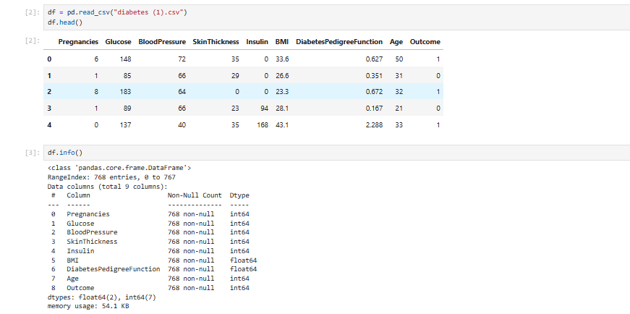

**Figure 1: Dataset loading and overview**

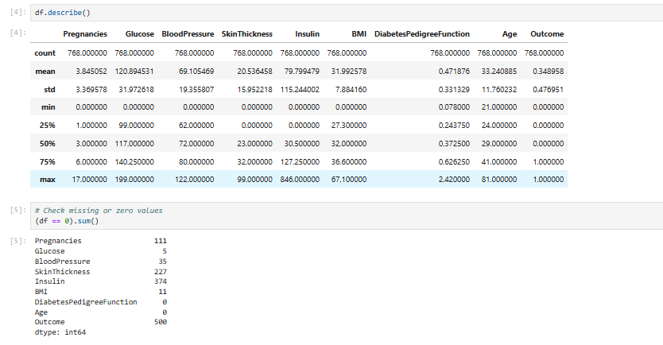

**Figure 2: Descriptive statistics and checking missing values**

It can be underscored from Figure 1 that the researcher uses the Panda library to load the Pima Indians Diabetes Dataset, which has 768 observations and 9 attributes. Also, it is underscored from Figure 2 that the dataset has missing values, which need to be eliminated to maintain data consistency.

## 5.2 Exploratory data analysis

The exploratory data analysis is developed to underscore the major insights from the dataset. This graphical analysis helps to determine patterns, trends as well and distribution.

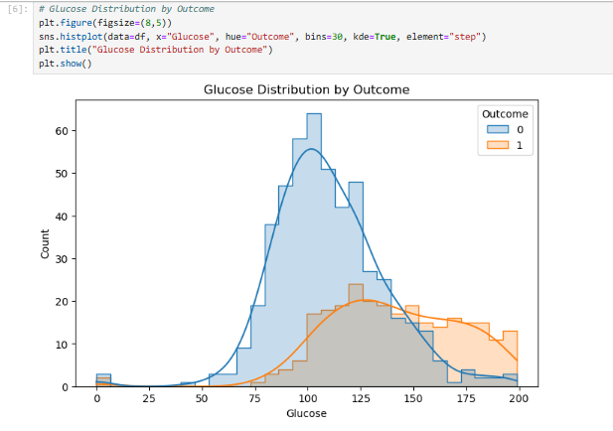

**Figure 3: Glucose Distribution by Outcome**

It has been underlined from Figure 3 that the histogram shows the distribution of the levels of glucose in diabetic (Outcome = 1) and non-diabetic (Outcome = 0) patients. The values of non-diabetic people are concentrated nearer to lower glucose levels (≈100), whereas those of diabetic patients are higher, showing an average and more distributed (>125). It means that glucose is a coherent predictor to determine diabetes.

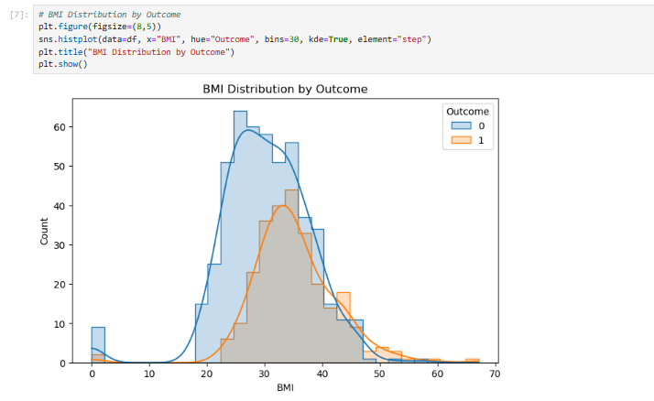

**Figure 4: BMI Distribution by Outcome**

The figure above (4) indicates the distribution of BMI which highlights the fact that diabetic patients are characterized by high BMI and non-diabetic patients by low BMI. The non-diabetics have been clustered at 25 BMI, and the diabetics around 30+. According to this analysis, the high BMI is a significant variable, which correlates with diabetes.

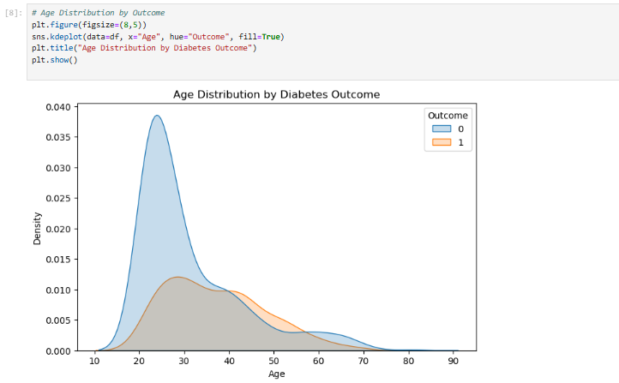

**Figure 5: Age Distribution by Outcome**

It has been emphasized in the figure (5) that the younger age group is not diabetic and individuals who are more than 35 years old display the fact that they are diabetic. According to this analysis, age is a significant factor, including the risk of diabetes has been increasing with age.

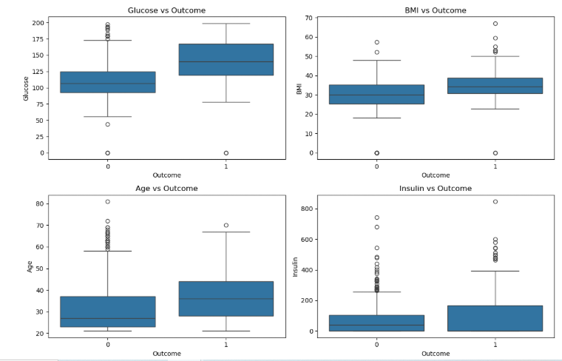

**Figure 6: Boxplots for Key Features**

The Figure 6 shows major differences in diabetic and non-diabetic groups. The glucose, BMI, age, and insulin levels tend to be larger among diabetic patients and are therefore cogent predictors of diabetes. The further dispersion and outliers reflect variability, particularly with regard to insulin values. Also, the above figure points high glucose levels, BMI, and age are major risk factors of diabetes.

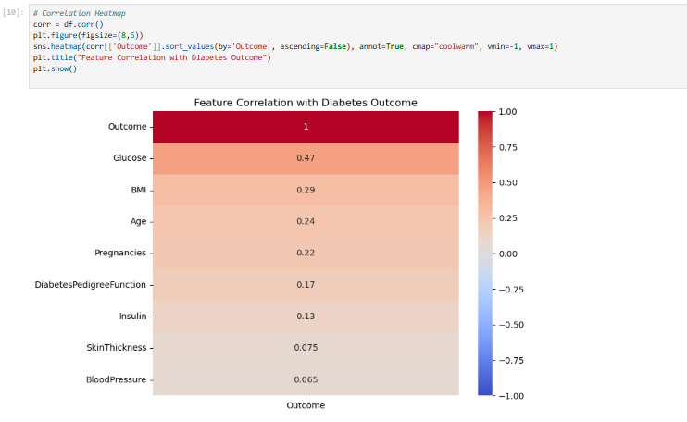

**Figure 7: Feature Correlation with Diabetes Outcome**

The above figure (7) shows the correlation heatmap and states that glucose has a positive correlation (0.47) with diabetes outcome, as well as other are BMI, age, and number of pregnancies. Features such as blood pressure and skin thickness show weak relationships. This states that glucose and BMI are effective predictors in determining diabetes.

## 5.3 Data Preprocessing

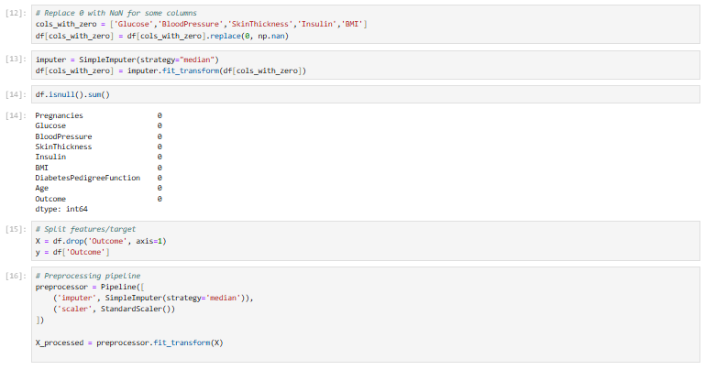

**Figure 8: Data Preprocessing**

Here, the researcher uses cogent preprocessing to prepare the dataset for ML modelling. The missing values are replaced with NAN and imputed with the help of median values to maintain cogent distributions. For maintaining consistency, the pipeline is developed with imputation and scaling with all features. This method is very beneficial for the Logistic Regression algorithm. The output shows that the dataset is clean, normalised, has no missing values and is suitable for training machine learning models.

## 5.4 Data splitting and model training

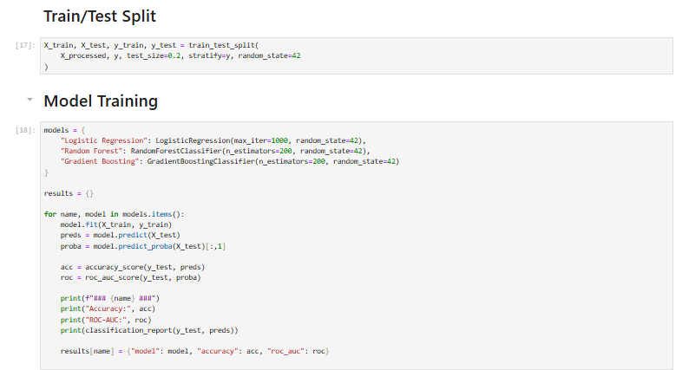

**Figure 9: Data splitting and model training**

Figure 9 shows that the researcher develops three classifiers in the preprocessed dataset as well as the models are “Logistic Regression, Random Forest, and Gradient Boosting”. The dataset is also split into an 80:20 ratio and uses a stratified split to confirm balanced class distribution. It is also determined from the above figure that the model will be evaluated with the help of accuracy, ROC-AUC and classification metrics.

# 6. Testing

This section is established to test the model performance and perform unit testing.

## 6.1 Model evaluation and cross-validation

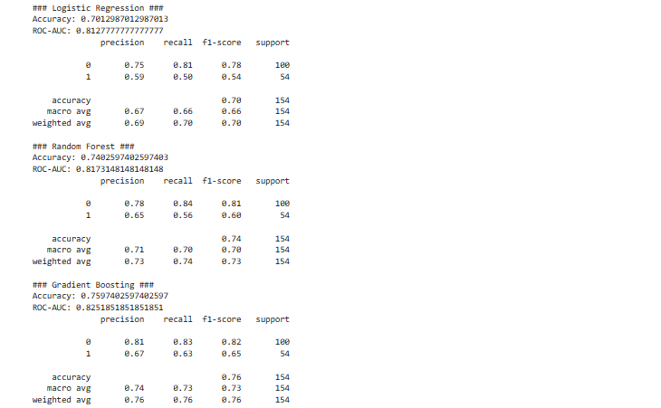

**Figure 10: Model evaluation of Logistic Regression, Random Forest, and Gradient Boosting**

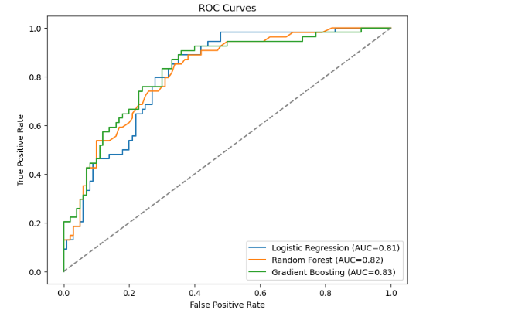

**Figure 11: ROC curves**

The model evaluation and comparison show that Gradient Boosting outperforms all models in terms of the highest accuracy, such as 76% and ROC-AUC (0.83). The model shows balanced performance to predict both classes. The Random Forest model also shows cogent performance, such as 0.74% accuracy and ROC-AUC (0.82), but can not outperform Gradient Boosting. As a baseline, logistic regression shows moderate performance, but it is recommended that management of healthcare use the Gradient Boosting model to accurately predict diabetes and make data-driven decisions.

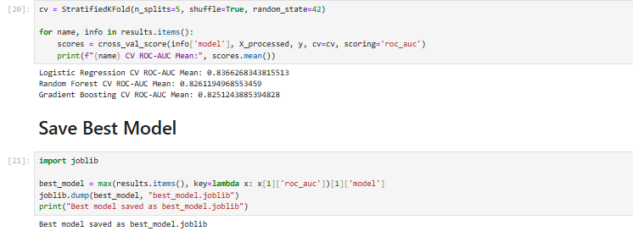

**Figure 12: Cross-Validation**

It has been underlined from the cross-validation that the Logistic Regression model achieves the highest mean ROC-AUC (≈0.84), and others are close to the LR model, such as the boosting model and the ensemble model achieve ≈0.83. Also, the best model has been saved using joblib, which confirms reproducibility and its use in the future to perform diabetes prediction exercises.

## 6.2 Unit testing

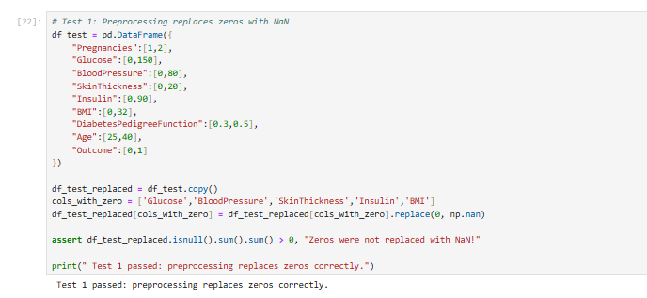

**Figure 13: Test 1: Preprocessing replaces zeros with NaN**

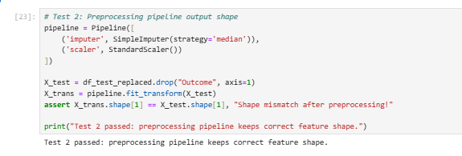

**Figure 14: Test 2: Preprocessing pipeline output shape**

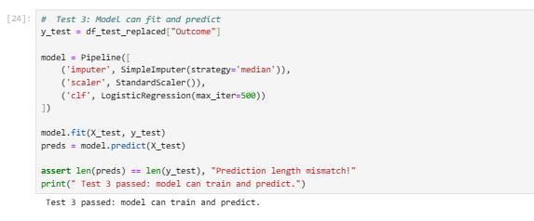

**Figure 15: Test 3: Model can fit and predict**

The preprocessing and modelling steps are trustworthy, as verified in the unit tests. Test 1 confirmed the presence of zeros that were substituted with NaNs in an accurate manner. The fact that the pipeline maintained feature dimensions following scaling and imputation was tested and confirmed in test 2. Test 3 validated the model in the ability to train and give predictions. This test has been confirming reproducible workflow that is accurate to be used in clinical data applications.

## 6.3 Workflow Validation (End-to-End Check)

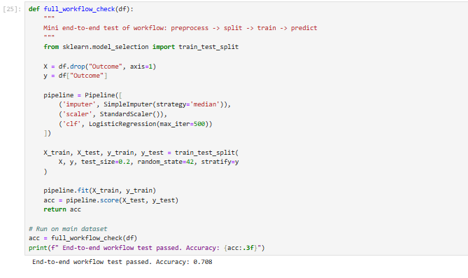

**Figure 16: Workflow Validation**

The end-to-end workflow validation shows that the accuracy of the pipeline at preprocessing to model training and prediction accuracy is 0.708. It has been determine from the workflow validation that the developed implementation is accurate, as well as confirming that it can be used in real world for predicting diabetes.

# 7. Discussion and Limitations

## 7.1 Discussion

The critical analysis of results states that machine learning has coherent effectiveness for developing accurate data-driven decisions for healthcare. With the help of gathering insights from predictive modelling, it is possible to determine the major risk factors of diabetes. It is seen from model evaluation that the Gradient Boosting model achieves the best accuracy and ROC-AUC, which underscores that the ensemble methods have the ability to determine nonlinear relationships in clinical data. Also, the Logistic Regression shows a cogent ROC-AUC (0.84) in cross-validation, stating a high consistency across folds, even though it had low test performance. The outcome points to the trade-off between the complexity and interpretability of the model, which is one of the central themes of the healthcare-related ML applications. Also, the critical analysis of various kinds of published journal articles shows coherent innovation and gaps. The comparison analysis of related studies shows that there are some important consistencies. The effectiveness of ensemble and deep learning models in predicting diabetes was also reported in previous research, including Naz and Ahuja (2020) and Abnoosian et al. (2023). Also, critical analysis of journals (Li et al., 2024; Hoyos et al., 2024) focused on optimisation and explainability, which is consistent with the focus of this project on the importance of balancing predictive ability and interpretability. The exploratory analysis also validated clinically familiar risk factors, such as high glucose levels, high body mass index, and ageing, which shows that ML methods can produce results that are aligned with medical knowledge, which is cogent to clinical credibility. Also, the pipeline that was used in Python delivered reproducibility and flexibility. The technical soundness of preprocessing, training and prediction has been validated through unit and workflow testing. These practices states the value of a strong evaluation, not just of academic research but also of clinical translation.

## 7.2 Limitations

With the various kinds of strength, the study has limitations which need to be considered to boost the accuracy of future work.

### 7.2.1 Dataset Size and Generalizability

The dataset analysis shows that Pima Indians Diabetes Dataset has 768 records of a particular population. Although accurate in benchmarking, the information is quite small and might not be reflective of populations across the world with different ethnic and lifestyle backgrounds. This decreases the extrinsic validity of the results.

### 7.2.2 Class Imbalance

It has been seen from the implementation section that the researcher uses stratified splitting, but also seen a medium level of class imbalance in diabetic and non-diabetic cases, which has affected the recall and sensitivity to minority cases. For healthcare sector it is very beneficial to decrease false negative, and other strategies like SMOTE or cost-sensitive learning may prove useful to accurately balance the dataset, which will be used in future work.

### 7.2.3 Limited Feature Scope

It is underscored from the dataset analysis that there are only limited features, such as glucose, BMI, age, and blood pressure. There are a large number of other significant risk factors that are missing, including family history, diet, genetics, and lifestyle. This limits the predictive power and clinical significance of this model.

### 7.2.4 Interpretability Challenges

The model evaluation shows that Logistic Regression deliver accurate interpretability, but the Random Forest and Gradient Boosting are black-box models, and it is more difficult to explain the predictions to clinicians. The techniques of explainable AI (e.g., SHAP, LIME) were not applied, but should be included in future research to address this gap.

### 7.2.5 Overfitting Risk

The difference between test and cross-validation results indicates that there is a potential possibility of overfitting the model, particularly with ensemble models. This problem can be addressed by increasing the size of the dataset or regularising and optimising hyperparameters.

### 7.2.6 Deployment and Ethical Considerations

The project did not involve clinical system or API testing. Also, ethical considerations like data privacy, equity among demographic subgroups, and possible algorithmic bias were not part of this research, but very beneficial to practical implementation.

# 8. Conclusion and Reflection

## 8.1 Conclusion

It can be concluded that this research showed that machine learning has the ability to effectively help early diabetes detection. It is underscored from the model performance that Logistic Regression uses as a baseline, as well as ensemble methods such as Random Forest and Gradient Boosting has been achieves coherent predictive power, also Gradient Boosting performed best and outperforms all models. Cross-validation and workflow validation confirmed trustworthiness. The project confirms the fact that computational techniques can be used to help healthcare professionals to determine individuals at risk of diabetes, and thus play a cogent role in preventive healthcare decision-making. Also, the research highlights the need to have model interpretability in the medical setting, where simpler models, such as the Logistic Regression, can have more benefits compared to complex ensembles. The study showed high reliability, reproducibility, and robustness in model performance by a rigorous pipeline, comprising preprocessing, validation and testing. Also, this project can not only add to the scholarly knowledge of machine learning in healthcare as well as shows practical demonstrations of how predictive analytics can be used to aid clinical decision systems in practice.

## 8.2 Reflection

With the help of this project, the researcher has been learn various data analysis, processing and modelling techniques, as well as critical analysis of literature has helped to discover major technological innovations and major research gaps. The use of Python and its libraries, scikit-learn, Pandas, Matplotlib, and NumPy, helped the researcher to better plan reproducible pipelines and systematic evaluation techniques. Developing unit and workflow tests enhanced the knowledge of software validation and reliability as important skills in research and professional development. The other valuable lesson gained throughout the experience was the necessity to control the version and collaborate with the assistance of GitHub to plan the projects and record them in a better way.

# References

Naz, H. and Ahuja, S., 2020. Deep learning approach for diabetes prediction using PIMA Indian dataset. *Journal of Diabetes & Metabolic Disorders*, *19*(1), pp.391-403.

Tasin, I., Nabil, T.U., Islam, S. and Khan, R., 2023. Diabetes prediction using machine learning and explainable AI techniques. *Healthcare technology letters*, *10*(1-2), pp.1-10.

Abnoosian, K., Farnoosh, R. and Behzadi, M.H., 2023. Prediction of diabetes disease using an ensemble of machine learning multi-classifier models. *BMC bioinformatics*, *24*(1), p.337.

Li, W., Peng, Y. and Peng, K., 2024. Diabetes prediction model based on GA-XGBoost and stacking ensemble algorithm. *PloS one*, *19*(9), p.e0311222.

Hoyos, W., Hoyos, K., Ruiz, R. and Aguilar, J., 2024. An explainable analysis of diabetes mellitus using statistical and artificial intelligence techniques. *BMC medical informatics and decision making*, *24*(1), p.383.

# Appendix: GitHub Repository

<https://github.com/SairamThout/Computer-Science-Project-DLMCSPCSP01-.git>